

ENG4052: Digital Communication 4 (2022-23)

Lab2: Carrier Recovery using Costas Loop

**Haoshi Huang (2635088H)**

**Submission Date**

**8/2/2023**

**1 Introduction**

Carrier recovery is a key technique during demodulation, the aim of which is to synchronise the carrier frequency of modulated signal at the receiving end to the local oscillator frequency. Although there are a variety of factors affecting modulated signals during transmission, using carrier recovery can make sure the correctness of demodulation signal partly.

In this lab, I will use Python3.10 in Visual Studio to program a **VCO** firstly, and then implement **Carrier Recovery** with the help of **Costas Loop** using **Cordic** algorithm (Coordinated Rotation Digital Computer) during demodulation. Libraries NumPy1.23, SciPy1.9 are imported to implement advanced math operation. Library matplotlib3.6 is used to display graphics, which can show how signal and parameters changes after processing.

**2 Numerically Controlled Oscillator**

**2.1 Create a Digital Clock**

An oscillator is an electronic component to generate a fixed frequency, controlled sine or cosine wave. A digital oscillator can simulate an oscillator operation. The code of NCO is shown in Fig. 2.1 and the digital signal of 100 samples is shown in Fig. 2.2. We can adjust the parameters f0 (frequency), p0 (phase) to control the output wave. When creating wave, the f0 and p0 are constant we set initially.

*Figure 2.1 Program NCO*

*Figure 2.2 Controlled cosine & sine wave*

**2.2 Voltage Controlled Oscillator**

On the basis of the NCO, we can add another parameter volt (voltage) to control frequency with voltage variation which varies with time. The frequency controlled by voltage can be expressed by following formular:

箱线图

fi is initial frequency. The code for VCO is shown in Fig. 2.3 and the output wave is shown in Fig. 2.4. We increase the voltage 10 times from 250 sample point, and then the wave frequency changed accordingly.

*Figure 2.3 Program VCO*

*Figure 2.4 Output of VCO*

**2.3 Cordic Algorithm**

Cordic algorithm is an algorithm which can quickly computes trigonometric functions’ value, with matrix multiplication under continuous iteration. In fact, the nature of matrix multiplication is angular rotation. According to the flow diagram in the Fig. 2.5, we can program a function called cordic as shown in the Fig. 2.6:

*Figure 2.5 Flow diagram of Digital Oscillator with Cordic algorithm*

*Figure 2.6 Cordic function*

**3 Carrier Recovery**

**3.1 Modulation**

During transmission, some factors may cause distortions of the modulated signal slightly, such frequency and phase of carrier wave. We use random function to simulate distortion. In this lab, we still use the same original coded information as BPSK project shown as Fig. 3.1. With the BPSK modulation, we can get the modulated signal shown as following Fig. 3.2. The number of samples per bit is 128. And we will sample 64 per period as ideal carrier frequency, meaning 1/64.

*Figure 3.1 Original signal*

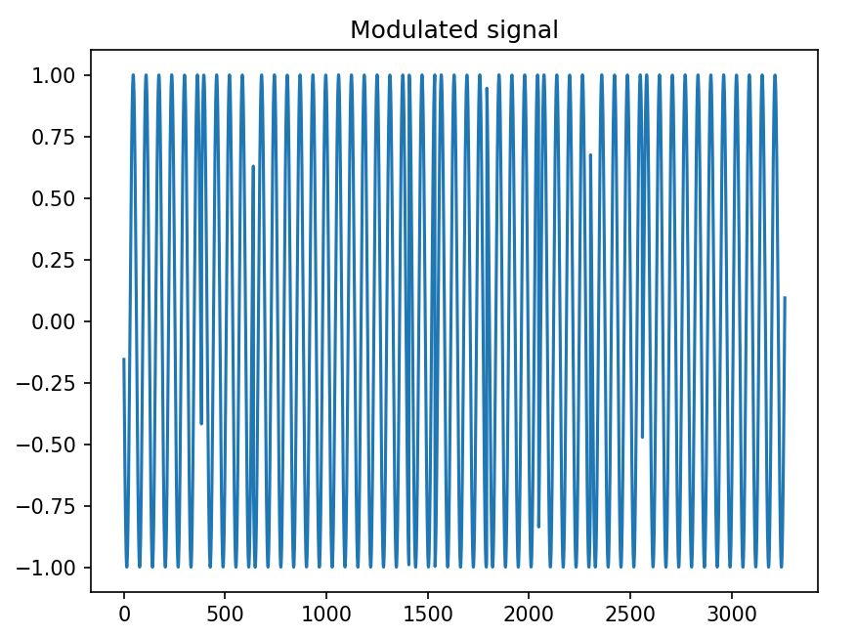

*Figure 3.2 Modulated signal by BPSK*

**3.2 Costas Loop with Cordic Algorithm**

In fact, Costas Loop can be considered as an advanced Phase-locked Loop (PLL). PLL just use one branch wave to circle; Costas Loop uses two orthogonal waves to loop as shown in the Fig. 3.3.

*Figure 3.3 Flow diagram of Costas Loop*

In the diagram, firstly we mixed I&Q components of modulation signal with VCO output respectively. Secondly, two branches mixed signal are filtered by the same low pass filters respectively. Finally, the two filtered branch signal multiply each other, which get voltage as the error to adjust the frequency of VCO output. In the Fig. 3.4 & 3.5, We can observe the adjustment process of voltage and frequency, and the frequency closes to the real carrier frequency at the end.

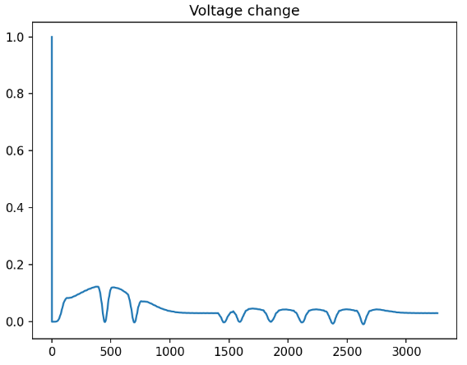

*Figure 3.4 Adjustment process of voltage*

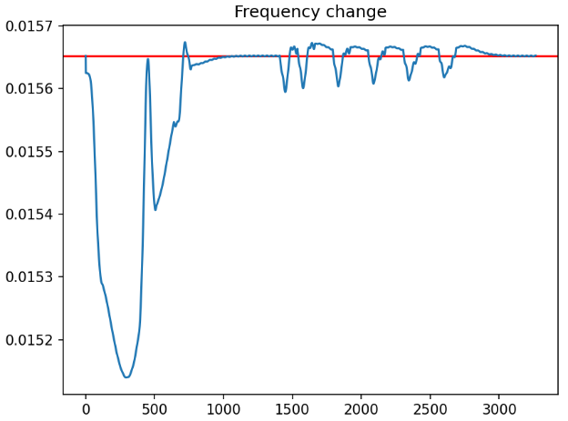

*Figure 3.5* Adjustment process *of frequency and fi*

We can draw the reference wave and self-adaption wave in the same plot. In the Fig. 3.6, the red wave and the bule wave become overlapping gradually.

Figure 3.6 Adjustment process of frequency and fi

After carrier recovery, we can get the whole output from the filtered cos branch wave as shown in the Fig. 3.7.

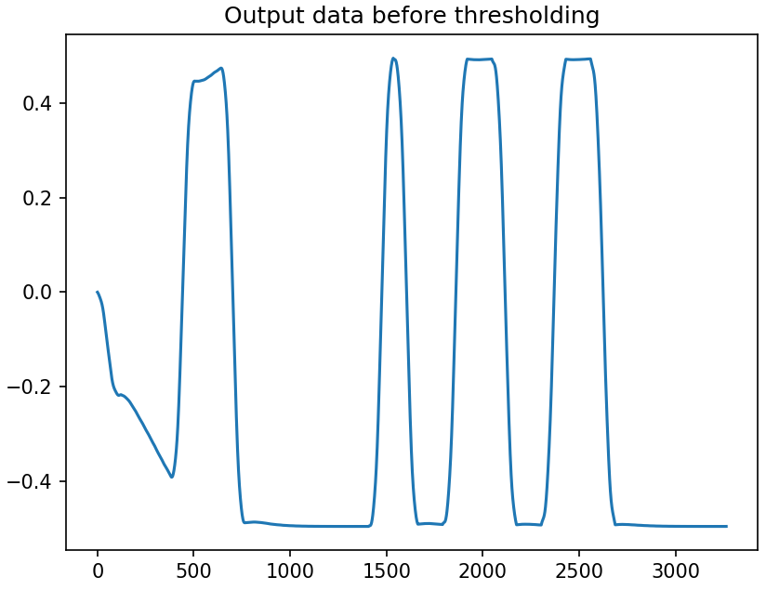

*Figure 3.7* Cos branch of Costas Loop after LPF

After thresholding, we can get the demodulated signal, which is the same as the original signal as shown in the Fig. 3.8.

*Figure 3.8* Demodulated signal with differential coding

**4 Conclusion**

**Demodulated signal with inverse phase sometimes**

During carrier recovery, the phase and frequency need to be adjusted to synchronize the modulated signal. If the phase has an great error, resulting in the inverse phase of demodulated signal after carrier recovery exactly comparing with original signal. To avoiding this situation, we need to use differential coding, meaning **XOR**, before the modulation and after the thresholding.

In the code, for comparison conveniently, we can use a on-off variable to change the partial code with or without differential coding. Setting on-off as “False” and running the code many times, in the Fig. 4.1 & 4.2, we can compare the result. The orange has inverse phase with the original coded information. And if we set on-off variable as “True”, we use differential code. The result of running code many times will only get the same signal as the original signal.

*Figure 4.1 Demodulated signal with the same phase*

*Figure 4.2 Demodulated signal with the inverse phase*

**Appendix:**

**NCO.py**

import numpy as np

from scipy import signal

from matplotlib import pyplot as plt

# initialise

nsamples = 100

clock = np.empty(shape=(2, nsamples))

f0 = 1/32

p0 = 0

w0 = 2*np.pi*f0

# generate two branch of digital clock

for t in range(nsamples):

clock[0, t] = np.cos(w0*t+p0)

clock[1, t] = np.sin(w0*t+p0)

fig = plt.figure()

ax1 = fig.add_subplot(211)

ax1.set_aspect(1)

ax1.plot(clock[0], clock[1])

ax1.plot(clock[0][0], clock[1][0], color='r')

ax1.set_xlabel('In-phase')

ax1.set_ylabel('Quadrature')

ax2 = fig.add_subplot(212)

ax2.plot(clock[0], color='r')

ax2.plot(clock[1])

ax2.legend(labels = ('cos', 'sin'))

ax2.set_xlabel('t')

ax2.set_ylabel('Amplitude')

plt.show()

**VCO.py**

import numpy as np

from scipy import signal

from matplotlib import pyplot as plt

# initialise

nsamples = 500

clock = np.empty(shape=(2, nsamples))

fi = 1/64

p0 = 0

alpha = 0.05

volt = 0.1

# generate two branch of digital clock

for t in range(nsamples):

f0 = fi + alpha * volt

w0 = 2*np.pi*f0

clock[0, t] = np.cos(w0*t+p0)

clock[1, t] = np.sin(w0*t+p0)

if (t == (nsamples // 2)):

volt *= 10

fig = plt.figure()

ax = fig.add_subplot(111)

ax.plot(clock[0], color='r')

ax.legend(labels = ('cos', 'sin'))

ax.set_xlabel('t')

ax.set_ylabel('Amplitude')

plt.show()

**CarrierRecovery.py**

'''

Author : Eureke

Date : 2023-02-08 16:10:41

LastEditors : Marcus Wong

LastEditTime : 2023-02-09 00:40:27

Description :

'''

import numpy as np

from matplotlib import pyplot as plt

from scipy import fft

from scipy import signal

from numpy import random

def bin_array(num, m):

# Convert a positive integer num into an m-bit bit vector

return np.array(list(np.binary_repr(num).zfill(m))).astype(bool)

id_num = 2635088

Nbits = 24

tx_bin = bin_array(id_num, Nbits)

# Show original signal

plt.figure()

plt.title('Original signal')

plt.plot(tx_bin)

plt.show()

s = tx_bin

# carrier wave ideal frequency

fi = 1/64

# samples per bit

bit_len = 128 # 64

withDiff = True

if (withDiff):

#Differential Coding of tx_bin

tx_diff = np.zeros(1, dtype='bool')

for i in range(Nbits):

tx_diff = np.append(tx_diff, tx_diff[i]^s[i])

Nbits = Nbits+1

else:

tx_diff = tx_bin

# low-pass filter

numtaps = 128 #64

b1 = np.flip(signal.firwin(numtaps, 0.005))

# initialise

clock = np.array([1.0,0.0])

# carrier radom frequency

f_c = fi*(1.+0.02*(random.rand()-0.5))

# carrier radom phase of carrier

p_c = 2*np.pi*random.rand()

# Modulation

s_mod = np.empty(0)

for t in range(0, bit_len*Nbits + numtaps//2):

s_mod = np.append(s_mod, (2*tx_diff[(t//bit_len)%Nbits]-1)*np.cos(p_c+2*np.pi*f_c*t))

plt.figure()

plt.title('Modulated signal')

plt.plot(s_mod)

plt.show()

fout = np.array(f_c)

volt = 1.0

# volt changes

vout = np.array(volt)

# output of clock cos wave

cout = clock[0]

# output of reference clock

rout = np.cos(p_c)

# demod output

dout = np.empty(0)

def cordic(clock, fi, volt):

alpha = 0.25

f0 = fi*(1.+alpha*volt)

w0 = 2*np.pi*f0

c = np.cos(w0)

s = np.sin(w0)

clock = np.matmul(np.array([[c, -s], [s, c]]), clock)

return clock, f0

mixed = np.zeros((2,numtaps))

for i in range(0, bit_len*Nbits + numtaps//2):

# modulated signal mixed with clock

mixed[0,:] = np.append(mixed[0,1:],clock[0]*s_mod[i])

mixed[1,:] = np.append(mixed[1,1:],-clock[1]*s_mod[i])

# lpf

lpmixed = [np.sum(b1*mixed[j,:]) for j in range(2)]

volt = lpmixed[0]*lpmixed[1]

clock, f0 = cordic(clock, fi, volt)

fout = np.append(fout, f0)

vout = np.append(vout, volt)

cout = np.append(cout, clock[0])

rout = np.append(rout, np.cos(p_c+2*np.pi*f_c*i)) #Reference block

dout = np.append(dout, lpmixed[0])

plt.figure()

plt.title('Voltage change')

plt.plot(vout)

plt.show()

plt.figure()

plt.title('Frequency change')

plt.axhline(f_c, color='r')

plt.plot(fout)

plt.show()

plt.figure()

plt.title('Clock output with reference carrier')

plt.plot(cout)

plt.plot(rout, color='r')

plt.show()

plt.figure()

plt.title('Output data before thresholding')

plt.plot(dout)

plt.show()

print(f_c)

print(fout[-1])

print(fout[-1] - f_c)

if (withDiff):

# With differential coding

rx_diff = np.empty(0)

for i in range(Nbits):

#select an appropriate sample point

k = (2*i+1)*bit_len//2 +numtaps//2

rx_diff= np.append(rx_diff, np.heaviside(dout[k],0))

rx_bin = np.empty(0, dtype='bool')

Nbits = Nbits-1

for i in range(Nbits):

rx_bin = np.append(rx_bin, rx_diff[i].astype(bool)^rx_diff[i+1].astype(bool))

# print(rx_bin)

plt.figure()

plt.title('With differential encoding')

plt.plot(rx_bin)

plt.show()

else:

# Without differential coding

rx_bin = np.empty(0, dtype='bool')

for i in range(0,Nbits):

t = (2*i+1)*bit_len//2 +numtaps//2

rx_bin = np.append(rx_bin, np.heaviside(dout[t],0))

if ((rx_bin != tx_bin).any()):

plt.figure()

plt.title('Without differential encoding but inverse phase')

plt.plot(rx_bin, color='orange')

plt.show()

else:

plt.figure()

plt.title('Without differential encoding but the same')

plt.plot(rx_bin)

plt.show()